4.4 Base44 for Building Lightweight Apps - Teacher's Demonstration Document
*** There are 2 demonstration’s options, choose one from them! ***
========

Demonstration #1: "FixMe" – Service Call Management System
Goal: Build a functional app for managing service tickets (קריאות שירות) using Base44. The app will allow users to submit issues, assign them to technicians, track their status, and send notifications. Estimated time: ~90 minutes.

1. Start a New Project in Base44
- Navigate to https://www.base44.com
- Click Start Building → Continue with Google
- In the start page, explain about:
  - The prompt window
  - The Styling Instructions option - adds specific styling instructions to your app design
  - The Upload option - let you upload references (i.e. code txt files of your prototyping, image of the design you want, etc.)
  - The Ideas section - to explore varied options
  - My Recent Apps section - where your apps will be presented
  - Docs & Support - can be handy for questions
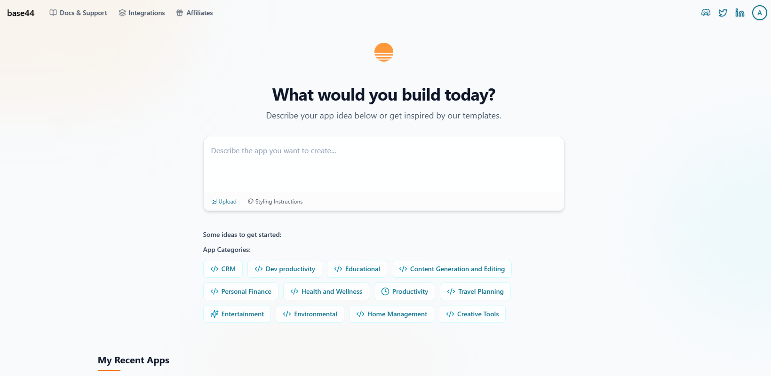

2. Write the initial prompt
I want to build an internal app for managing service tickets in a company. Users should be able to submit a new service request by filling in the title, description, and location. Each request should have a status (Open, In Progress, Resolved) and be assigned to a technician. Technicians should have a dashboard showing only the requests assigned to them, with the ability to update the status. There should also be an admin panel for assigning technicians and viewing all requests. Please create the database structure, basic UI, and logic flows.
Tips! - Plan and prototype first with a less-costly LLM (i.e. Claude, Gemini, ChatGPT)

2. Go over the High-Level Planning it generates
- Explain to them about how it connects to the technical lecture about essential developing concepts: It defines Key Features, Design Language. App Organization
- Then, it starts building:
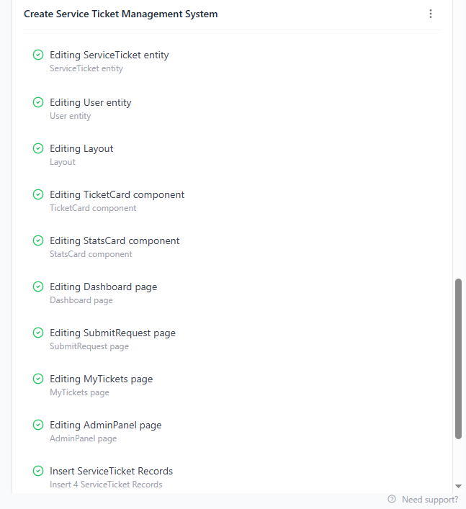

3. Go over the output via the Preview option
Play with the app and explore whether it does what you want it to do.
https://app--service-flow-09b39b0e.base44.app
For example, in the website above, users can submit requests, and the admin can see all of the open requests in his panel, but he can’t actually assign technicians to a ticket. This is an important functionality bug that should be fixed.
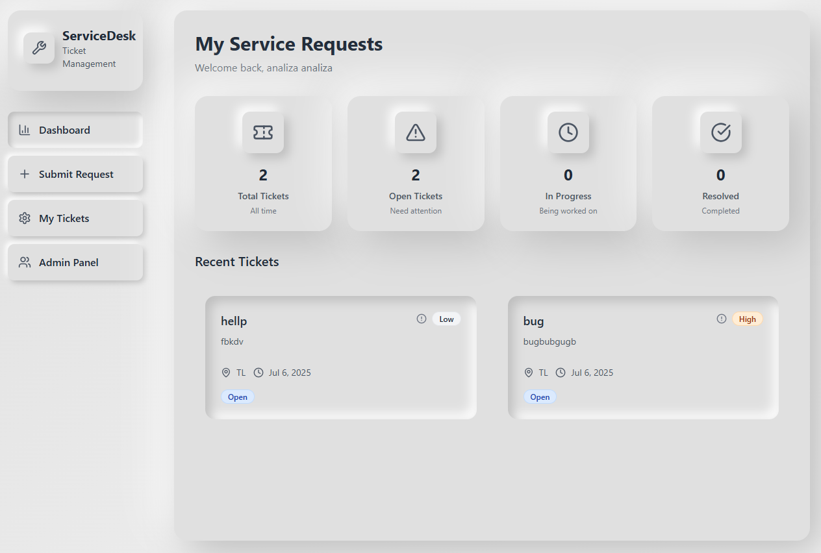

4. Go over the Workspace
Explore and explain about each option:
- Overview - apps name and description, apps visibility, invite users, share app
- Users - which users allowed to the app. You can define the scheme of the users (via prompts to my knowledge).
In the app being an example, you have 3 roles: Admin (who assigns tickets to technicians), technician (who receives tickets), and user (who open tickets).
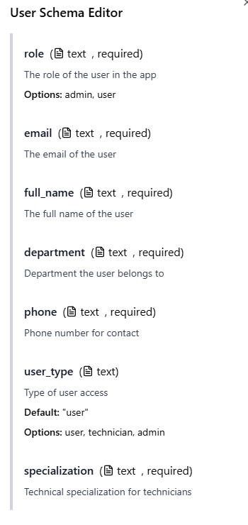
- Data - a DB of mongoDB is automatically associated with your app! You can also change the scheme of your DB (via prompts to my knowledge)
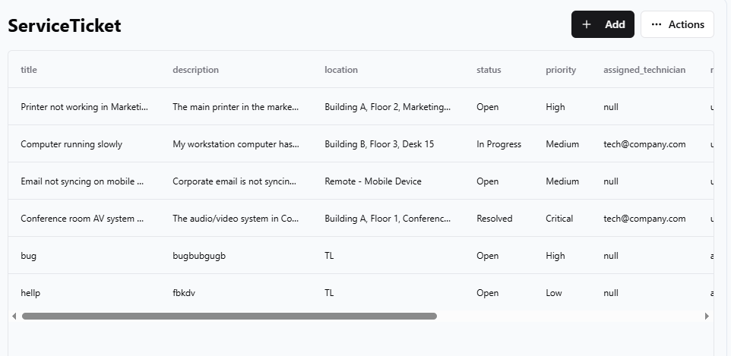
- Analytics - an automatic dashboard is created to your app. You can change it via prompts. Great for monitoring, exploring user’s behavior, etc.
- Domain - Base44 gives you an auto-generated domain, but you can purchase one and integrate it to your app easily via their instructions.
- Security - You can set security rules to different users of your app. For example, the users will be able to see only their tickets and not other tickets.
- Code - where you see your code! Paid options can edit it and export to Git
- Logs - the logs of your app
- API - where you can connect your app to APIs. You can do that also via the prompt window.
- Settings -
  - Logo - Change your app logo
  - App Settings -
    - Change authentication in your app (default is with authentication)
    - clone app (for exploring changes you want to do without messing with your current working version)
    - backend functions - only for paid customers.
    - delete app - no backwards..!

5. Explain how to Publish the app
Press on the Publish button and copy the URL.
You can also invite users by email.

6. Explore improving your initial output!
Write a prompt to improve the app based on the changes you want to make. Write the prompt and see what happens!
Remember - You have limited prompts (in the free of course but also in the paid plans it isn’t endless), so you should be calculated..!
Show the “revert” option - like control Z == if you don't like the changes followed by your prompt you can revert it.

Demonstration #2: "FormFlow" – Build-Your-Own Form and Analyze Submissions
Goal: Build a dynamic form-builder app where users can create custom forms, share them, collect responses, and view results. The app will cover form creation, data collection, and analysis, using Base44.

Exact same steps as in Demonstration #1, only different prompt:

I want to build an app that lets users create their own forms, share them, and collect responses. The app should include: a form creation page (with form name and creator), a page to fill out the selected form, and a dashboard page that shows all the responses and basic analysis (like charts). Each response should be tied to the relevant form. Please build the database, UI pages, and flows.

